**STUDENT INDUSTRIAL WORK EXPERIENCE SCHEME (SIWES)**

**UNDERTAKEN AT FEDERAL MEDICAL CENTER, LOKOJA**

**KOGI STATE, NIGERIA**

**BY**

**NAME: MEDAIYESE FATIMOH O.**

**MATRIC NUMBER: (SCI/16/CSC/089)**

**DEPARTMENT OF COMPUTER SCIENCE,**

**FACULTY OF SCIENCE**

**FEDERAL UNIVERSITY LOKOJA**

**JULY – DECEMBER, 2019.**

# DECLARATION

I, MEDAIYESE FATIMOH.O. declare that this write up is a technical report of my activities and experience acquired during the SIWES period. This report is written by me under the supervision of MR MALIK ADEIZA RUFAI. The information derived from the literature has been duly acknowledged in the text and a list of reference provided.

_______________________________ _____________________

Signature

Date

# CERTIFICATION

I certify that this is a technical report of SIWES activities undertaken by MEDAIYESE FATIMOH O. at FEDERAL MEDICAL CENTER, LOKOJA, KOGI STATE, NIGERIA.

_________________________________ ___________________

Mr. Malik Adeiza Rufai

Departmental SIWES Coordinator

Date

__________________________________  ___________________

Dr. Tanko Dauda

Institution’s SIWES Coordinator

Date

# 

# 

# ACKNOWLEDGEMENT

First, I’m grateful to God, the giver of life, wisdom, knowledge and understanding.

My appreciation goes to the Industrial Training Fund (ITF) for their foresight in organizing and managing this program and also to the Computer Science Department, Federal University Lokoja for providing me with a platform on which I was engaged on the training.

A big thank you to my family for their love, support, care and encouragement throughout the period of the SIWES program.

I’m grateful to FMC, for providing me with the opportunity to be exposed to the world of Information Technology and for their encouragement and support financially.

My appreciation also goes to my institution based supervisor MR MALIK ADEIZA RUFAI for the encouragement during the visitation/supervision.

# 

# ABSTRACT

The Industrial Report presents the experience I gained during my 24 weeks of Industrial training undertaken at FEDERAL MEDICAL CENTER, Lokoja, Kogi State.

My training was on Word Processing Packages, Spreadsheets Packages, PowerPoint, Basic C# Programming, Networking, Hardware Repairs.

I am glad to say that I acquired practical knowledge on:

* How to create a Microsoft Word Document using a Word Processing Package.
* How to use Shortcut Keys.
* How to create a Spreadsheet work using a Spreadsheet Package.
* How to create a Presentation using PowerPoint.
* Basic C# Programing.
* Networking.
* Hardware Repairs.

This report discusses the practical skills I acquired during the training and also justifying it relevance in all that I have learnt in the class room and equipping me with the needed practical competence to thrive in the real world.

# Table of Contents

DECLARATION iii

CERTIFICATION iv

ACKNOWLEDGEMENT v

ABSTRACT vi

Table of Contents vii

List of Figures ix

CHAPTER ONE 1

1.0 Introduction 1

CHAPTER TWO 2

Historical Review of SIWES and Organization 2

2.1 Definition and Origin of SIWES 2

2.2 Objectives of SIWES 2

2.3 Brief history of Federal Medical Center, Lokoja, Kogi State 3

2.3.2 Mission Statement 4

2.3.3 Objectives of the Agency 4

2.3.4 Their Responsibilities are as follows: 4

2.3.5 Departments/Units 5

2.4 Organizational Chart of Federal Medical Center, Lokoja, Kogi State 6

CHAPTER THREE 7

Activities during SIWES 7

2.5 Word Processing Package 7

2.5.1 What is Word Processing Package? 7

2.5.2 What is Microsoft Word? 7

2.6 Important Microsoft Word ToolBars 8

The Home Tab 8

The Insert Tab 9

The Design Tab 10

The Layout Tab 11

The References Tab 11

The Review Tab 12

The View Tab. 13

3.1 Microsoft Excel 14

4.1 PowerPoint 15

5.1 Networking 16

5.1.1 Network Topology 17

5.1.2 The OSI Model 17

5.1.3 Network Cables 18

6.1 Basic C# Programming 22

6.1.1 Simple Operations 23

6.1.2 Arrays 24

6.1.3 Other Numerical Operations 25

6.1.4 Strings 25

7.1 Hardware Repair 25

7.1.3 Identify hardware Peripherals 30

7.1.4 Basic Knowledge of safeguarding hardware 31

CHAPTER 4 32

Summary, Conclusion and Recommendation 32

6.1 Summary 32

6.2 Conclusion 32

6.3 Recommendation 33

References 34

# List of Figures

Figure 2.1 Organizational chart of FMC Lokoja……………………………….6

Figure 3.5.1 Home Tab……………………………………………………………...9

Figure 3.5.2 Insert Tab…….…………………………………………………………10

Figure 3.5.3 Design Tab……………………………………………………………...10

Figure 3.5.5 Layout Tab ……………………………………………………………12

Figure 3.5.6 References Tab………………………………………………………...13

Figure 3.5.7 Review Tab…………………………………………………………...13

Figure 4.1 View Tab………………………………………………………………14

Fig 5.1.1 Network Topology…………………….……………………………...17

Fig 5.1.2 The OSI Model………………………………19

Fig 5.1.3 Network Cables………………………………………………………21

Fig 5.1.4 Computer hardware Tools ………………………...21

Fig 7.1.3 Identify hardware Peripheral………………………………………30

# CHAPTER ONE

## 1.0 Introduction

The Student Industrial Work Experience Scheme (SIWES) was established by the Industrial Training Fund (ITF) with it ultimate purpose to help students in the University, Polytechnic and Colleges of Technology acquire technical/practical knowledge in their various field of studies. SIWES is a six (6) months program for students of various tertiary institution, with its aim to bridge the gap between theoretical knowledge and practical knowledge to enhance student for a real work situation.

This report details my activities during my six (6) months industrial training at FMC, Lokoja, Kogi State. During this period, I was opportune to be introduced to Word Processing, Spreadsheet and PowerPoint Packages, Basic C# Programming, Networking, Hardware Repair.

I was also opportune to learn under professional computer scientists in the field, they were of great help in bridging the gap between all that I have learnt in the class and real work situation. Industrial Training Fund was indeed right when they started the program because it has been of great help to me in equipping me for my career.

# CHAPTER TWO

## Historical Review of SIWES and Organization

## 2.1 Definition and Origin of SIWES

The Student Industrial Work Experience Scheme (SIWES) was established by the Industrial Training Fund (ITF) with it ultimate purpose to help students in the University, Polytechnic and Colleges of Technology acquire technical/practical knowledge in their various field of studies. Over the years SIWES has become an integral part of academic standard and a requirement for the successful completion and award of Bachelor of Science Degree in Nigeria. Undoubtedly, SIWES has contributed immensely to developing the common pool of technical/practical skills available to the Nigerian economy which in turn has helped a great deal in the nation’s industrial development. Also, SIWES provides students of higher institution of learning with the ease of transition from school to the world of work and it also enhances student contacts for later job. Students of higher institutions get the opportunity to familiarize themselves and be exposed to the needed experience in handling machinery and equipment which are not available at the institution of learning.

Although the duration of training program varies from tertiary institution to another, it is four months for Polytechnics and Colleges of Education, and six months for Universities.

## 2.2 Objectives of SIWES

Below are some of the basic Objectives of SIWES and they form the bed rock of why it was established:

1. One of its aim is to bridge the gap between the theoretical knowledge acquired by students of various institution in the class and the technical/practical knowledge in the industries by creating a platform for the student to apply what they have learnt in the real work situation.
2. Students of higher institutions get the opportunity to familiarize themselves and be exposed to the needed experience in handling machinery and equipment which are not available at the institution of learning.
3. Also, SIWES provides students of higher institution of learning with the ease of transition from school to the world of work and it also enhances student contacts for later job.
4. It also provides students with the privilege to work with professionals in the field and help them narrow down their course of study to what they love doing for a successful career.
5. To create an avenue for employers of labor to get involve in the educational process in preparing student of tertiary institution for later employment.
6. Finally, it provides student with the avenue to be part of a team where they get to learn to work together to complete project and will eventually be of great help in their career.

## 2.3 Brief history of FMC Lokoja

ISP Computer Institute was established on 20th March, 2002 by the Managing Director Mr. Titus Emeka. The institute was created initially to cater to system repairs and maintenance before expanding to include other departments and that was when the institute was really “born”. The institute expanding gave rise to higher visions and goals which it (the institute) has vowed to fulfill to its fullest capability.

**2.3.1 Vision Statement**

A Healthy Society for Sustainable development in Kogi State.

### 2.3.2 Mission Statement

To ensure a transparent, competitive, inclusive, sustainable system that ensures propagation of world-class healthcare services in Kogi State.

### 2.3.3 Objectives of the Agency

The objectives of the agency are listed below:

1. To provide efficient and quality health care services.
2. To ensure the provision of safe, affordable, adequate, equitable and accessible health services to all people.

### 2.3.4 Their Responsibilities are as follows:

1. Regulating, coordinating and supervising the activities within the hospital.
2. To provide a conducive environment for patients i.e. (Cleanliness & Neatness in All Areas of the Hospital).

### 2.3.5 Departments/Units

FMC Lokoja comprises of the following departments/units all of which work together in order to achieve the vision and mission of the agency:

1. IT (Information Technology)
2. Library
3. Doctors & Nurses
4. Admin
5. Pediatrics

## 

## 2.4 Organizational Chart of Lagos State Public Procurement Agency

Managing Director

Assistant Managing Director

Manager

Doctors

& Nurses

Admin

IT (Information Technology

Library

Pediatrics

Fig 2.1: Organizational Chart of FMC Lokoja, Kogi State

# 

# CHAPTER THREE

## Activities during SIWES

I resumed at FMC Lokoja on the 15th July, 2019, where I was posted to the IT (Industrial Training) & Education department. The department is responsible for providing IT students with the necessary skill sets necessary to excel in their various fields, some of the services which include managing the IT students, providing the necessary lessons needed to learn a particular skill.

## 2.5 Word Processing Package

### 2.5.1 What is Microsoft Word?

Microsoft Word is one of the most popular word processing package. Microsoft Word can be used to create document, leaflets, list, outlines, resumes, and simple web page.

### 2.5.2 Important Microsoft Word Toolbars

Microsoft Word uses a toolbar and main ribbon to allow you to modify your document. 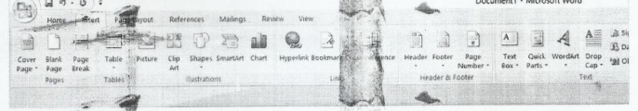

### Home Tab: is a Microsoft Word’s standard view. This is the view mostly widely used and allow you to format text by Font size, Font style, Bold, Italic, Underline, Alignment, Numbered List, Bulleted List, Font Color, Spacing and Indentation. C:\Users\Teemar\Pictures\Camera Roll\Capture3.PNG

### Insert Tab: This contains any additive you want to place in your document, including Tables, Online Picture/Clip Art searches, Headers and Footers. C:\Users\Teemar\Pictures\Camera Roll\Capture4.PNG

### Design Tab: It contains different styles of page formatting. When you type, your layout will automatically match the format selected. It also allows you to change the color scheme and paragraph spacing of your document. C:\Users\Teemar\Pictures\Camera Roll\Capture5.PNG

### Layout Tab: It contains icons for page setup and paragraph actions such as Margin, Orientation, Size, and Color. C:\Users\Teemar\Pictures\Camera Roll\Capture6.PNG

### References Tab: It allows you add Table of content, Footnotes, Bibliographic Information, Indexes and Citation. C:\Users\Teemar\Pictures\Camera Roll\Capture7.PNG

### Review Tab: This is where one can find spellings and grammar, the built in Thesaurus and Dictionary, Track changes, Check Word Count, and Show/Add Comment. C:\Users\Teemar\Pictures\Camera Roll\Capture8.PNG

### View Tab amongst others: It allows you to change the view of your document. C:\Users\Teemar\Pictures\Camera Roll\Capture9.PNG

**3.1 Microsoft Excel**

This is a spreadsheet package, it is used for Calculation, storing, Searching and manipulation of data. It can display data as line graphs, histograms and chart, and with a very limited three-dimensional graphical display, it also has a programming aspect. 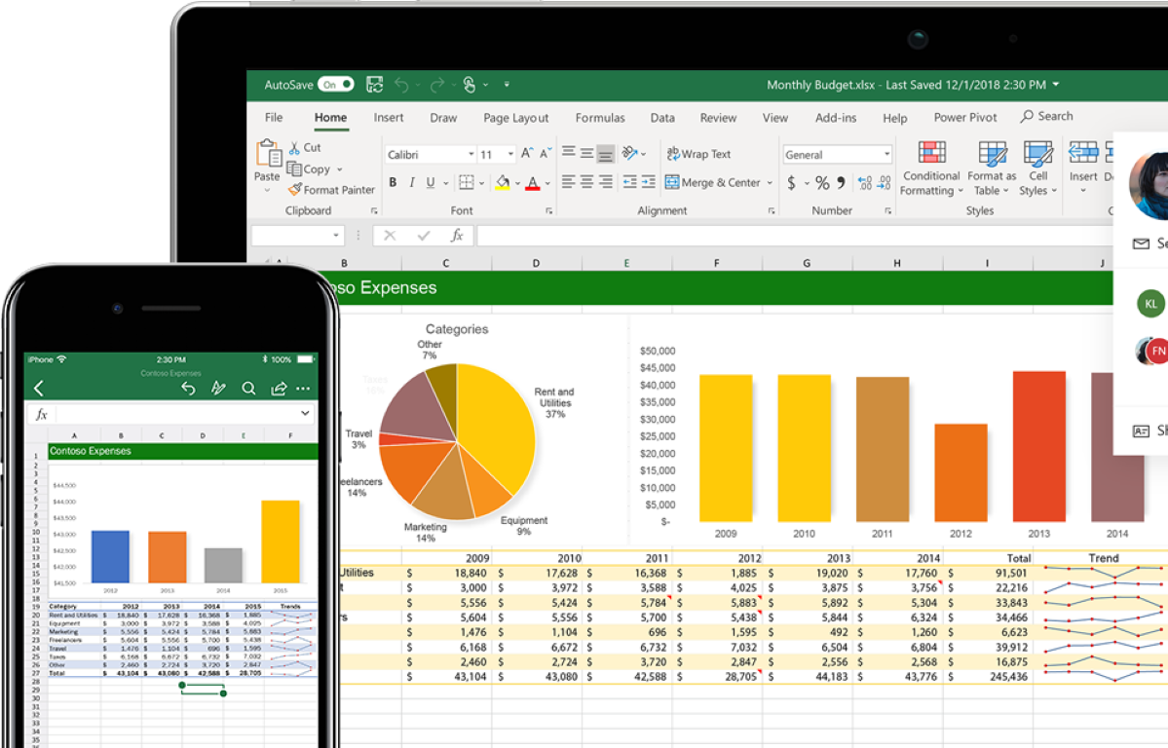

4.1.1 Microsoft Excel Environment

**Why Should I Learn Microsoft Excel?**

We all deal with numbers in one way or the other. We all have daily expenses which we pay for from the monthly income that we earn. For one to spend wisely, they will need to know their income vs. expenditure. Microsoft Excel comes in handy when we want to record, analyze and store such numeric data.

How to Open Microsoft Excel?

Running Excel is not different from running any other Windows program. If you are running Windows with a GUI like (Windows XP, Vista, and 7) follow the following steps.

Click on start menu

Point to all programs

Point to Microsoft Excel

Click on Microsoft Excel

Alternatively, you can also open it from the start menu if it has been added there. You can also open it from the desktop shortcut if you have created one.

### The Excel window

Many items you see on the Excel XP screen are standard in most other Microsoft software programs like Word, PowerPoint, and previous versions of Excel, while some elements are specific to Excel XP.

#### Workbook: Also called a spreadsheet, the workbook is a unique file created by Excel XP.

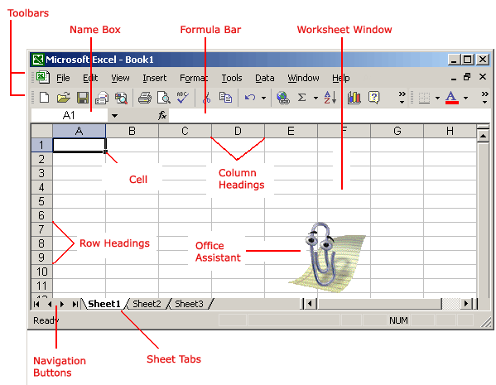

**Title bar*:***The title bar displays both the name of the application and the name of the spreadsheet. 

Fig. 14

**Menu bar*:***The menu bar displays all of the menus available for use in Excel XP. The contents of any menu can be displayed by left-clicking the menu name.



Fig. 15

#### Toolbar

Some commands in the menus have pictures or icons associated with them. These pictures may also appear as shortcuts in the toolbar.

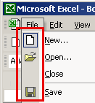 Fig. 16

#### Column headings



Fig. 17

Each Excel spreadsheet contains 256 columns. Each column is named by a letter or combination of letters.

#### Row headings

 Fig. 18

Each spreadsheet contains 65,536 rows. Each row is named by a number.

**Name box*:***This shows the address of the current selection or active cell.



Fig. 19

#### Formula bar



Fig. 20

The formula bar is plays information entered—or being entered as you type—in the current or active cell. The contents of a cell can also be edited in the formula bar.

### The cell

An Excel worksheet is made up of columns and rows. Where these columns and rows intersect, they form little boxes called **cells**. The active cell—or the cell that can be acted upon—reveals a dark border. All other cells reveal a light gray border. Each cell has a name. Its name is comprised of two parts: the column letter and the row number.

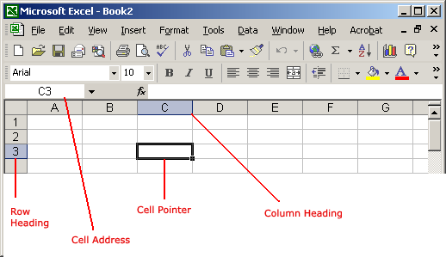

Fig. 21

In the following picture, the cell C3—formed by the intersection of column C and row 3—contains the dark border. It is the active cell.

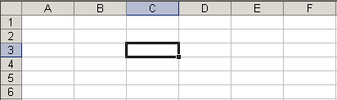Fig. 22

**Some of the exercises done using Microsoft Excel**

**Computing Students Results**

 Fig. 23



**3.1.1 PowerPoint**

This is a presentation package that offers users many ways to display information from simple presentation to complex multimedia presentation.

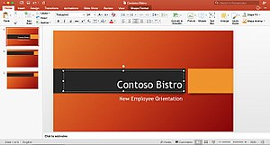

#### The PowerPoint Window

The PowerPoint window contains many elements that are similar to other Microsoft Office programs. These elements include the Office button, Quick Access toolbar, Title bar, Tabs, scroll bars and a Status bar.

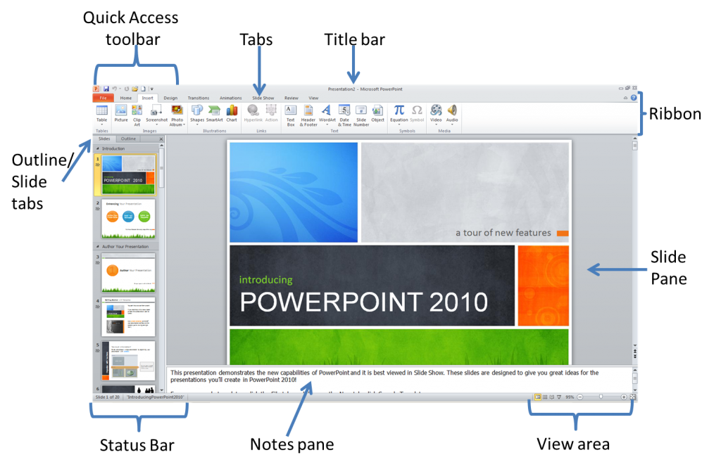 Fig. 25

**Quick access toolbar**contains buttons for commonly-used commands.

**Title bar** indicates the software, the name of the presentation that is open, minimize, maximize, and close buttons.

**Tabs** contain commands that are pided into related tasks called groups.

**Ribbon**is the area containing the tabs.

**Outline/Slides tab**displays the presentation text in the form of an outline. Outline tab is used to organize and develop the content of your presentation. This tab enables you to move slides and text by dragging selected material. Slide tab displays the slides of your presentation as small images. This view allows easy navigation through slides.

**Slide pane** contains the current slide in your presentation. You can use the vertical scroll bar to view other slides in the presentation.

**Notes pane** is located below the slide pane and is used to type reference notes. The notes can be printed, then referenced when making the presentation.

**View area** is located at the right hand bottom of the screen. It contains buttons that allow the ability to switch between PowerPoint views. The first view button allows you to view slides in normal view, the second is called the slide sorter view, the third is called the reader view and the fourth is called the slide show view. This area also contains the zoom feature.

**Status bar** is located at the bottom of the PowerPoint window, it shows messages and information about the view, such as the slide number and the current theme template used.

4.1 **Networking**

**What is a Network?**

A network is refer to two or more connected computers that can share resources such as data, a printer, an Internet connection, application or a combination of these resources. 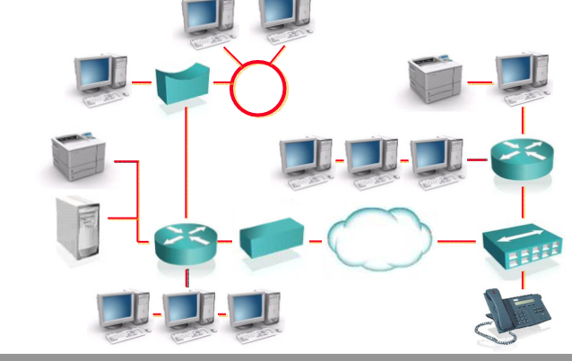

4.1.1 **Types of Network**

Local Area Network (**LAN**)

A Local Area Network (LAN) is a network that is confined to a relatively small area. It is generally limited to a geographic area such as a writing lab, school, or building.

Computers connected to a network are broadly categorized as servers or workstations. Servers are generally not used by humans directly, but rather run continuously to provide "services" to the other computers (and their human users) on the network. Services provided can include printing and faxing, software hosting, file storage and sharing, messaging, data storage and retrieval, complete access control (security) for the network's resources, and many others.

Metropolitan Area Network (**MAN**)

Wide Area Networks (WANs) connect networks in larger geographic areas, such as Florida, the United States, or the world. Dedicated transoceanic cabling or satellite uplinks may be used to connect this type of global network.

Wide Area Network (**WAN**)

Metropolitan Area Network (MAN) These types of networks are larger than LANs but smaller than WANs – and incorporate elements from both types of networks. MANs span an entire geographic area (typically a town or city, but sometimes a campus). Ownership and maintenance is handled by either a single person or company (a local council, a large company, etc.).

**Network Topologies**

Bus Topology

Bus topology is a network type in which every computer and network device is connected to single cable. When it has exactly two endpoints, then it is called Linear Bus topology.

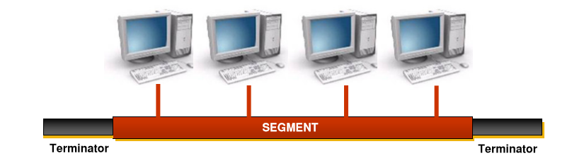

Features of Bus Topology

1. It transmits data only in one direction.

2. Every device is connected to a single cable

Advantages of Bus Topology

1. It is cost effective.

2. Cable required is least compared to other network topology.

3. Used in small networks.

4. It is easy to understand.

5. Easy to expand joining two cables together.

Disadvantages of Bus Topology

1. Cables fails then whole network fails.

2. If network traffic is heavy or nodes are more the performance of the network decreases.

3. Cable has a limited length.

4. It is slower than the ring topology.

Star Topology

In this type of topology all the computers are connected to a single hub through a cable. This hub is the central node and all others nodes are connected to the central node.

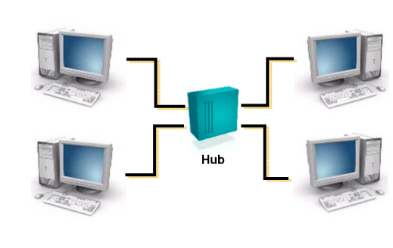

Features of Star Topology

1. Every node has its own dedicated connection to the hub.

2. Hub acts as a repeater for data flow.

3. Can be used with twisted pair, Optical Fibre or coaxial cable.

Advantages of Star Topology

1. Fast performance with few nodes and low network traffic.

2. Hub can be upgraded easily.

3. Easy to troubleshoot.

4. Easy to setup and modify.

5. Only that node is affected which has failed, rest of the nodes can work smoothly.

Disadvantages of Star Topology

1. Cost of installation is high.

2. Expensive to use.

3. If the hub fails then the whole network is stopped because all the nodes depend on the hub.

4. Performance is based on the hub that is it depends on its capacity

**Ring topology** – computers and devices are connected to a closed loop cable. Here there are no terminating ends so if one system crashes the entire network goes down. Each computer functions as a repeater and charges the signal before sending it to the next station.

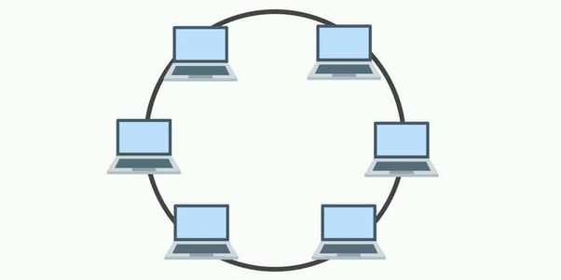

Features of Ring Topology

1. A number of repeaters are used for Ring topology with large number of nodes, because if someone wants to send some data to the last node in the ring topology with 100 nodes, then the data will have to pass through 99 nodes to reach the 100th node. Hence to prevent data loss repeaters are used in the network.

2. The transmission is unidirectional, but it can be made bidirectional by having 2 connections between each Network Node, it is called Dual Ring Topology.

3. In Dual Ring Topology, two ring networks are formed, and data flow is in opposite direction in them. Also, if one ring fails, the second ring can act as a backup, to keep the network up.

4. Data is transferred in a sequential manner that is bit by bit. Data transmitted, has to pass through each node of the network, till the destination node.

Advantages of Ring Topology

1. Transmitting network is not affected by high traffic or by adding more nodes, as only the nodes having tokens can transmit data.

2. Cheap to install and expand

Disadvantages of Ring Topology

1. Troubleshooting is difficult in ring topology.

2. Adding or deleting the computers disturbs the network activity.

3. Failure of one computer disturbs the whole network.

Mesh Topology

is a type of networking where all nodes cooperate to distribute data amongst each other? This **topology** was originally developed 30+ years ago for military applications, but today, they are typically used for things like home automation, smart HVAC control, and smart buildings.

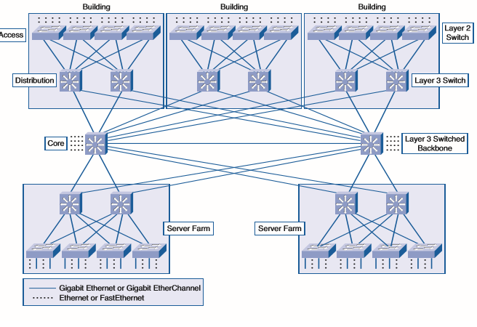

Features of Mesh Topology

1. Fully connected.

2. Robust.

3. Not flexible.

Advantages of Mesh Topology

1. Each connection can carry its own data load.

2. It is robust.

3. Fault is diagnosed easily.

4. Provides security and privacy.

Disadvantages of Mesh Topology

1. Installation and configuration is difficult.

2. Cabling cost is more.

3. Bulk wiring is required.

* + 1. **The OSI (Open System Inter-connection) Model**

This is conceptual model also known as seven layers model which was organization for the development of communality in function and interface between communication protocols.

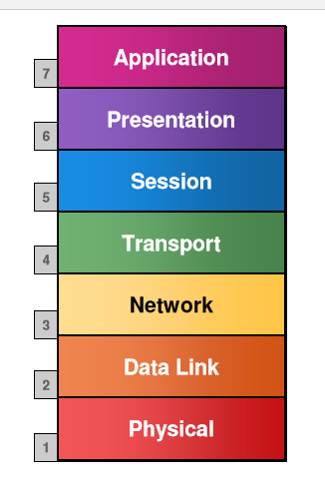

**Application layer Functions (upper layers)**

Network processes to application

Data representation

Inter-Host communication

**Transport Functions**

**End to End Connections:**

Handles transportation issues between hosts

Ensure data transport reliability

Establishes, Maintains and Terminates virtual circuits

Information flows controls

**Network layer**

**Data delivery:**

Provides connectivity and path selection between two host

Routes data packets

Select best path to deliver data

**Data link layer**

**Access to Media:**

It defines how data is formatted for transmission and to access network is controlled

**Physical layer**

**Binary Transmission:**

It defines the electrical, mechanical, procedure and functional specifications for activating, maintaining, and deactivating the physical link.

|  |  |  |  |  |
| --- | --- | --- | --- | --- |
| **OSI model** | | | | |
| **Layer** | | | [**Protocol data unit**](https://en.wikipedia.org/wiki/Protocol_data_unit)**(PDU)** | **Function**[[6]](https://en.wikipedia.org/wiki/OSI_model#cite_note-6) |
| **Host layers** | 7 | [Application](https://en.wikipedia.org/wiki/Application_layer) | [Data](https://en.wikipedia.org/wiki/Data_(computing)) | High-level [APIs](https://en.wikipedia.org/wiki/API), including resource sharing, remote file access |
| 6 | [Presentation](https://en.wikipedia.org/wiki/Presentation_layer) | Translation of data between a networking service and an application; including [character encoding](https://en.wikipedia.org/wiki/Character_encoding), [data compression](https://en.wikipedia.org/wiki/Data_compression) and [encryption/decryption](https://en.wikipedia.org/wiki/Encryption) |
| 5 | [Session](https://en.wikipedia.org/wiki/Session_layer) | Managing communication [sessions](https://en.wikipedia.org/wiki/Session_(computer_science)), i.e., continuous exchange of information in the form of multiple back-and-forth transmissions between two nodes |
| 4 | [Transport](https://en.wikipedia.org/wiki/Transport_layer) | [Segment](https://en.wikipedia.org/wiki/Packet_segmentation), [Datagram](https://en.wikipedia.org/wiki/Datagram) | Reliable transmission of data segments between points on a network, including [segmentation](https://en.wikipedia.org/wiki/Packet_segmentation), [acknowledgement](https://en.wikipedia.org/wiki/Acknowledgement_(data_networks)) and [multiplexing](https://en.wikipedia.org/wiki/Multiplexing) |
| **Media layers** | 3 | [Network](https://en.wikipedia.org/wiki/Network_layer) | [Packet](https://en.wikipedia.org/wiki/Network_packet) | Structuring and managing a multi-node network, including [addressing](https://en.wikipedia.org/wiki/Address_space), [routing](https://en.wikipedia.org/wiki/Routing) and [traffic control](https://en.wikipedia.org/wiki/Network_traffic_control) |
| 2 | [Data link](https://en.wikipedia.org/wiki/Data_link_layer) | [Frame](https://en.wikipedia.org/wiki/Frame_(networking)) | Reliable transmission of data frames between two nodes connected by a physical layer |
| 1 | [Physical](https://en.wikipedia.org/wiki/Physical_layer) | [Symbol](https://en.wikipedia.org/wiki/Symbol_rate#Symbols) | Transmission and reception of raw bit streams over a physical medium |

* + 1. **Network Cables**

We have three types of network cables they are Twisted-pair cable, Coaxial cable, and the Fiber Optics cable.

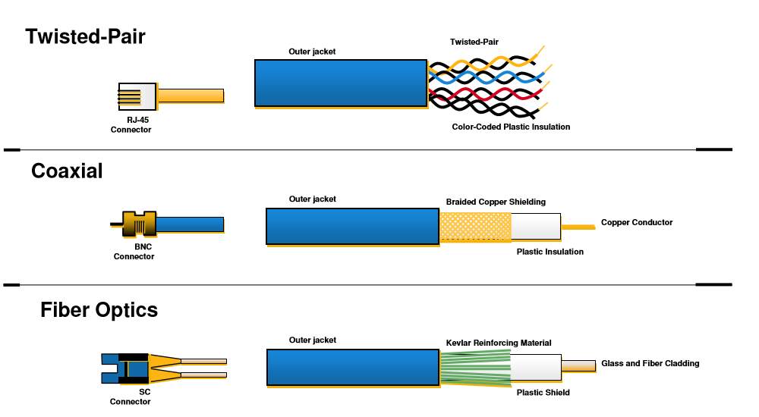

**Coaxial Cables**

Invented in the 1880s, coaxial cable (also called coax) was best known as the kind of cable that connected television sets to home antennas. Coaxial cable is also a standard for 10 Mbps

Ethernet cables .

When 10 Mbps Ethernet was most popular, during the 1980s and early 1990s, networks typically used one of two kinds of coax cable — thinnet (10BASE2 standard) or thicknet (10BASE5). These cables consist of an inner copper wire of varying thickness surrounded by insulation and another shielding. Their stiffness caused network administrators difficulty when installing and maintaining thinnet and thicknet.

**Twisted Pair Cables**

Twisted pair emerged during the 1990s as the leading cabling standard for Ethernet, starting with 10 Mbps (10BASE-T, also known as Category 3 or Cat3), later followed by improved versions for 100 Mbps (100BASE-TX, Cat5, and Cat5e) and successively higher speeds up to 10 Gbps (10GBASE-T). Ethernet twisted pair cables contain up to eight wires wound together in pairs to minimize electromagnetic interference.

Two primary types of twisted pair cable industry standards have been defined: unshielded twisted pair (UTP) and shielded twisted pair (STP). Modern Ethernet cables use UTP wiring due to its lower cost, while STP cabling can be found in other types of networks such as Fiber Distributed Data Interface (FDDI).

**Fiber Optics**

Instead of insulated metal wires transmitting electrical signals, fiber optic network cables use strands of glass and pulses of light. These network cables are bendable despite being made of glass. They have proven especially useful in

wide area network (WAN) installations where long-distance underground or outdoor cable runs are required and also in office buildings where a high volume of communication traffic is common.

Two primary types of fiber optic cable industry standards are defined — single-mode (100BaseBX standard) and multimode (100BaseSX standard). Long-distance telecommunications networks commonly use single-mode for its relatively higher bandwidth capacity, while local networks typically use multimode due to its lower cost.

5.1 **Basic C# Programming**

**What is C#?**

**C#** is an elegant object-oriented language that enables developers to build a variety of secure and robust applications that run on the .**NET Framework**. You can use C# to create Windows applications, Web services, mobile applications, client-server applications, and much more.

**My First C# Program**

Let’s start off by creating a short program that displays “Hello World!”.

In C#, we use the **Console.WriteLine** statement to output text

Static void Main (string [] args)

{

**Console.WriteLine** (‘Hello World!’);

}

Hello World!

**Printing Text**

The **Console.WriteLine** statement can also be used to output multiple lines of text.

**For Example:**

**Console.WriteLine** (‘Hello World!’)

Hello World!

**Console.WriteLine** (‘Hello world!’)

Hello world!

**Console.WriteLine** (‘Spam and eggs’)

Spam and eggs

Note that C# also include **IDLE**, the integrated development environment, which includes tools for writing and debugging entire programs.

5.1.1 **Simple Operations**

C# has the capability of carrying out calculations.

Enter a calculation directly into the C# console and it will output the answer.

Static void Main (string [] args)

{

int x = 10

double y = 20

**Console.WriteLine** (“x = {0}; y = {1}”, x, y);

}

// output : x = 10; y = 20

C# can also carry out multiplication and division, using an **asterisk** to indicate multiplication and a **forward slash** to indicate division.

Use **parentheses** to determine which operations are performed first.

Static void Main (string [] args)

{

int x = 20

double y = 10

**Console.WriteLine** (x -y);

}

//output 10

{

int x = 2

double y = 10

**Console.WriteLine** (x *y);

}

//output 20

5.1.2 **Array**

Array stores values of homogenous data type

**How to create an Array**

**Syntax**

**int [ ] n = new int [ 5 ];**

**double [ ] Fatimah = new double [ 20 ];**

**string [ ] tope = new string [ 10 ];**

5.1.4 **Strings**

If you want to use text in C#, you have to use a **string**.

A string is creating by entering text between **two single or double quotation marks**.

When the C# console displays a string, it generally uses single quotes. The delimiter used for a string doesn’t affect how it behaves in any way.

**Console.WriteLine** (“C# is fun!”)

‘C# is fun!’

**Console.WriteLine** (‘Always look on the bright side of life’)

‘Always look on the bright side of life’.

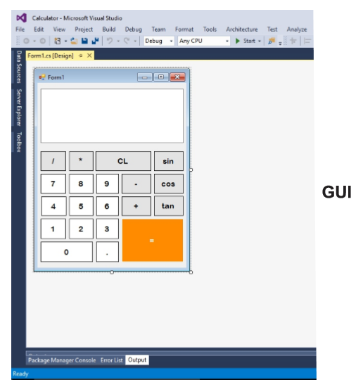

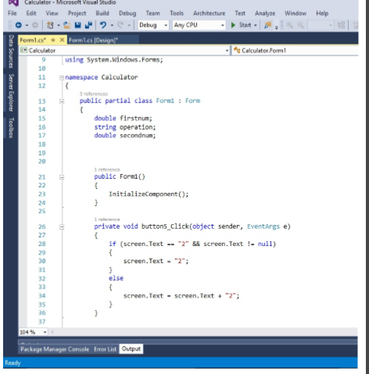

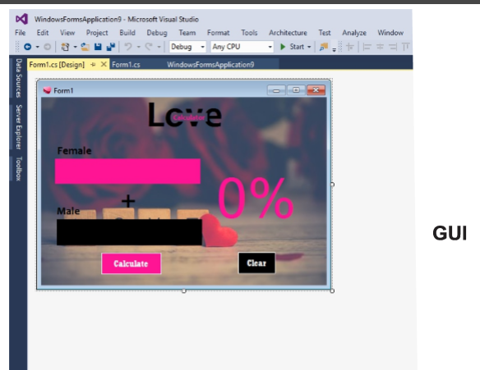

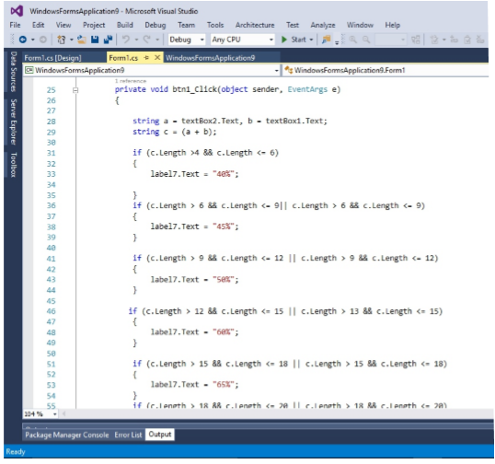

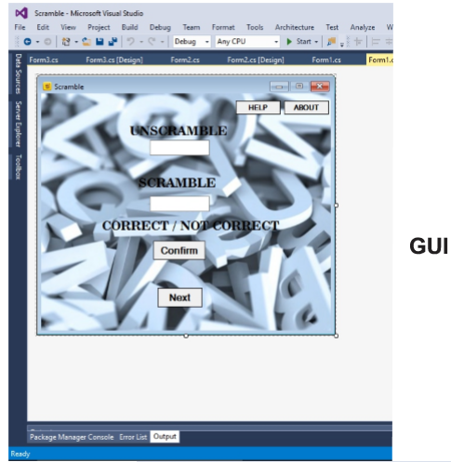

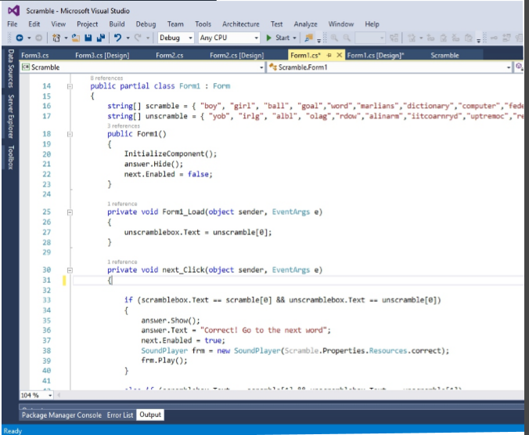

**Hardware Repairs**

**What is hardware?**

Hardware represent the physical and tangible component of a computer i.e the component that can be seen and touched.

Examples of hardware are as follows

Input devices: keyboard, mouse etc

Output devices: printer, monitor, speaker.

Secondary storage devices: hard disk, cd, dvd.

Internal components: cpu, motherboard, ram,

**Identifying hardware peripherals**

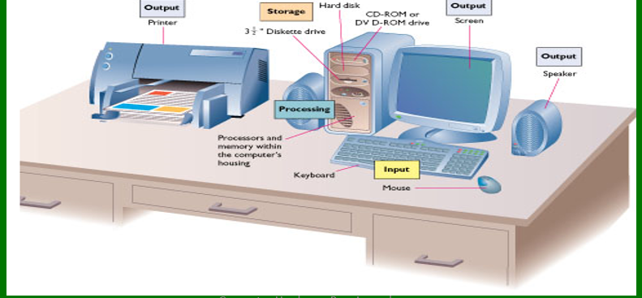

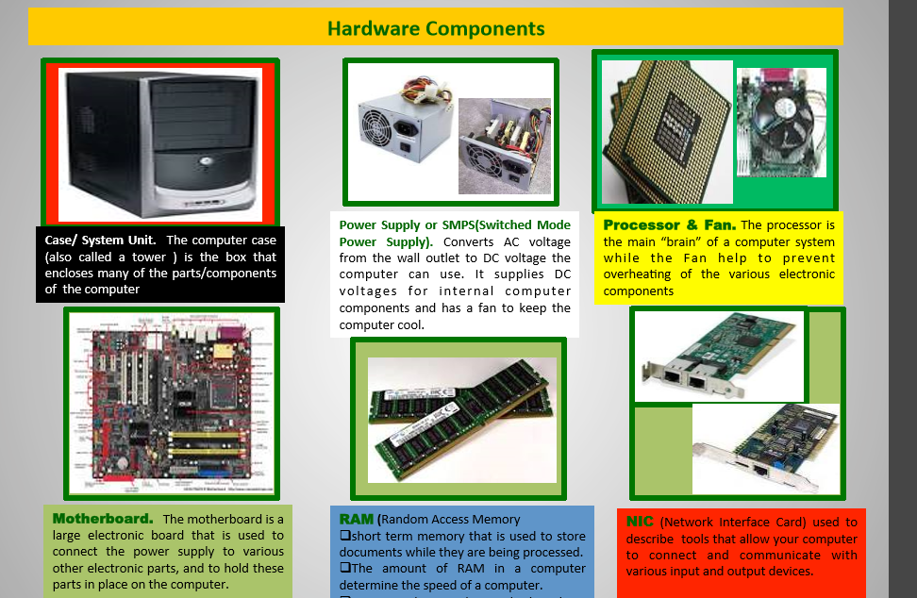

**Basic knowledge of safeguarding hardware**

Check harmful materials e.g. dust, virus, outdated software, faulty electrical Power/ gadget e.g. cables, sockets, extensions etc.

Check any malfunction of peripherals.

 Proper maintenance helps to keep the computer running smoothly for years.

# CHAPTER FOUR

## Summary, Conclusion and Recommendation

## 6.1 Summary

My first week at FMC Lokoja was more of entry level introduction to graphical designs, creating their templates, trying to blend creative elements in order and get a vivid and interactive design.

I continued on my six-month journey of industrial experience as I learnt about Word Processing, Spreadsheet and PowerPoint Packages, Basic C# Programming, Networking, Hardware Repair.

6.2 Conclusion

I’m glad to have undertaken my six-month industrial training program at FMC Lokoja Kogi State, because I have been able to improve much more on my computer based knowledge and skills. I got to apply some of what I learnt in school in term of word Processing, and was also introduced to new and interesting things like Basic C# Programming, Networking and Hardware Repair. The most important thing I learnt from my place of attachment with is working as an individual and also as part of a team because through this process you can effectively and efficiently acquire skills to contribute to your team as a whole and you as an individual too, my research skill greatly improved.

Also, I was privileged to work with professionals and some of the greatest minds in the field of Computer Science as a whole and has helped me narrow down the part of Computer Science that I really have a passion for.

## 6.3 Recommendation

I would humbly like to recommend the Student Industrial Work Experience Scheme program to all student of various tertiary institution as it helps shapes student career life and help prepare them for labor force market in order not to feel overwhelmed and out of place. It improves confidence and smartness when out in the real work world. I will also recommend that ITF enhances its relationship with all students involved in the program to give the student more confidence that what they are doing is worth it.

Also, locating the right place to undertake the training is one of the major problems in regards to industrial training therefore, I humbly recommend that ITF should help aspiring students identify a well-organized and trusted establishment in order to help students acquire the necessary and needed skills in their field of study.

# References

Agu, Z. (2018, February 12). *Aims and objectives of SIWES in Nigeria*. Retrieved from Legit: https://www.legit.ng/1143857-aims-objectives-siwes-nigeria.html

*Web Browser*. (2016, November 2). Retrieved from Wikipedia: https://en.m.wikipedia.org/wiki/Web_browser